Limit Switches, Electronics Tray, and LCD Screen

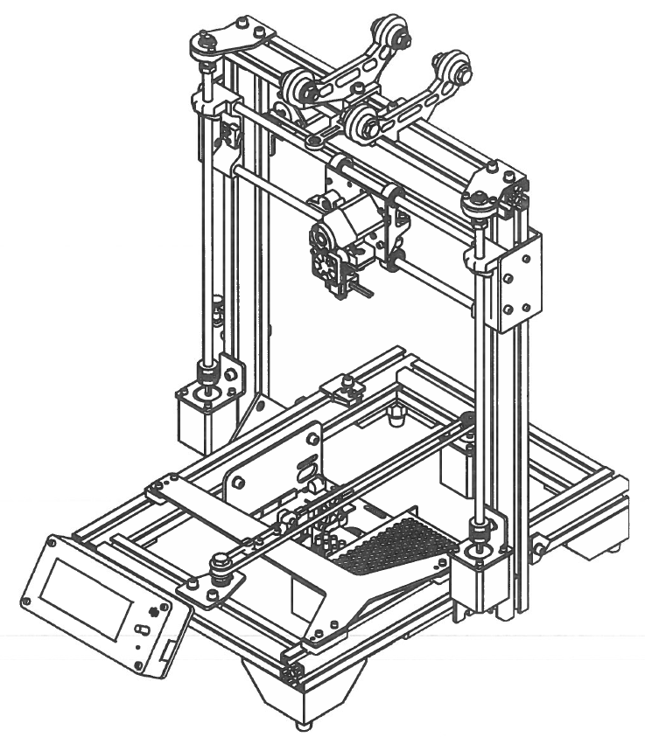

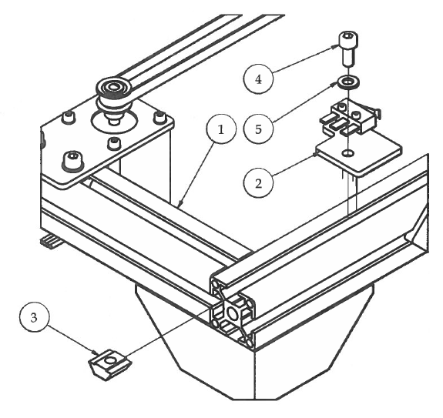Step 1

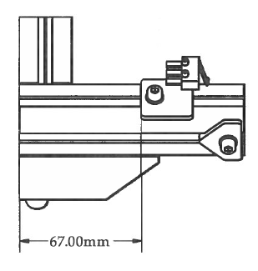

1. Attach the Y Limit Switch sub-assembly using M5 hardware.
2. The Y Limit Switch bracket 67mm from the back of the 3D printer.

|  |  |  |  |
| --- | --- | --- | --- |
| **PARTS LIST** | | | |
| **ITEM** | **QTY** | **PART NUMBER** | **DESCRIPTION** |
| 1 | 1 | X Stage Assembly | Previous sub-assembly |
| 2 | 1 | Y Limit Switch | Previous sub-assembly |
| 3 | 1 | M5 T-Nut | Nuts and bolts |
| 4 | 1 | M5 x 12 | Nuts and bolts |
| 5 | 1 | M5 Washer | Nuts and bolts |
|  |  | M4 Hex Wrench | Tools |

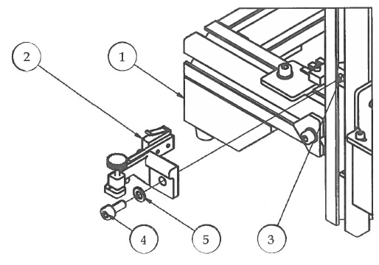Step 2

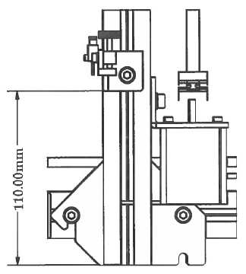

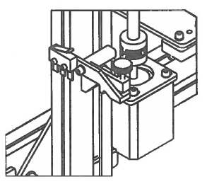

1. Slide M5 T-Nut into the outer slot of the left upright frame.
2. Attach Adjustable Z Limit Switch using M5 hardware measuring 110mm from the bottom of the extrusion. We will calibrate the position of this switch during the final calibration stage of assembly.

|  |  |  |  |
| --- | --- | --- | --- |
| **PARTS LIST** | | | |
| **ITEM** | **QTY** | **PART NUMBER** | **DESCRIPTION** |
| 1 | 1 | Step1 | Previous sub-assembly |
| 2 | 1 | Adjustable Z Limit Switch | Nuts and bolts |
| 3 | 1 | M5 T-Nut | Nuts and bolts |
| 4 | 1 | M5 x 12 | Nuts and bolts |
| 5 | 1 | M5 Washer | Nuts and bolts |
|  |  | M4 Hex Wrench | Tools |

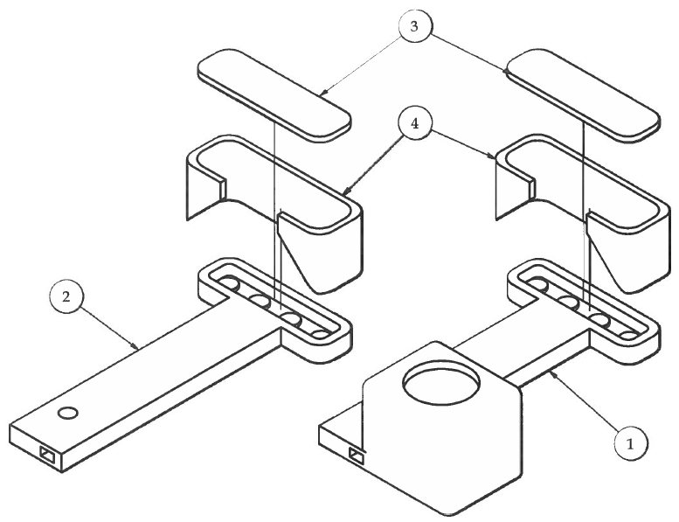Step 3

1. Press fit the LED lights into the LED light fixtures and solder them in a series circuit.
2. Solder wires to the LED light series circuits and run the wires through the small tubes inside the light post. (See "Super Bright 3D Printer Lights" on Thingiverse.com for detailed electrical assembly instructions).
3. Carefully attach the ledShade around the LED lights on each of the ledPost sub-assemblies. Leave about 2mm of the back side of the ledShade sticking out.
4. Snap in the ledCover plate on the back of the ledShade to cover the solder joints from the LED lights.

|  |  |  |  |
| --- | --- | --- | --- |
| **PARTS LIST** | | | |
| **ITEM** | **QTY** | **PART NUMBER** | **DESCRIPTION** |
| 1 | 1 | ledPostSwitch | Previous sub-assembly |
| 2 | 1 | ledPost | Previous sub-assembly |
| 3 | 2 | ledCover | 3D printed parts |
| 4 | 2 | ledShade | 3D printed parts |

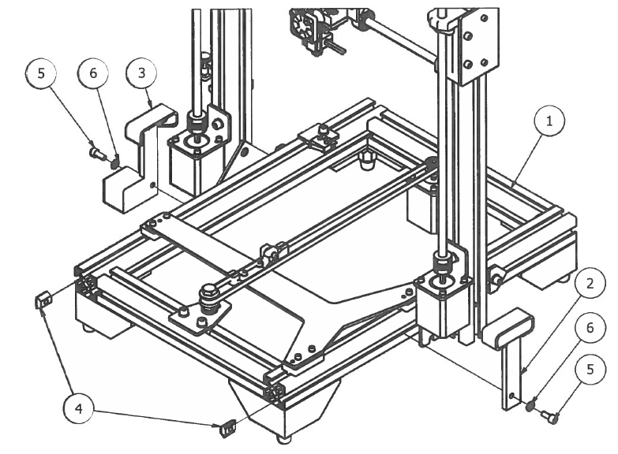Step 4

1. Attach both LED light fixtures to the bottom frame by sliding the LED light fixtures up against the Z motor brackets and attach using I-Nuts and M5 hardware.

|  |  |  |  |
| --- | --- | --- | --- |
| **PARTS LIST** | | | |
| **ITEM** | **QTY** | **PART NUMBER** | **DESCRIPTION** |
| 1 | 1 | Step1 | Previous sub-assembly |
| 2 | 1 | LEDpostAssy | Previous sub-assembly |
| 3 | 1 | LEDpostSwitchAssy | Previous sub-assembly |
| 4 | 2 | M5 T-Nut | Nuts and bolts |
| 5 | 2 | M5 x 12 | Nuts and bolts |
| 6 | 2 | M5 Washer | Nuts and bolts |
|  |  | M4 Hex Wrench | Tools |

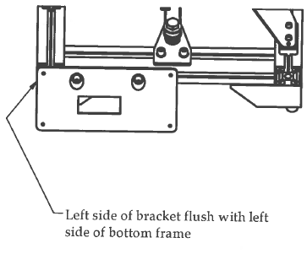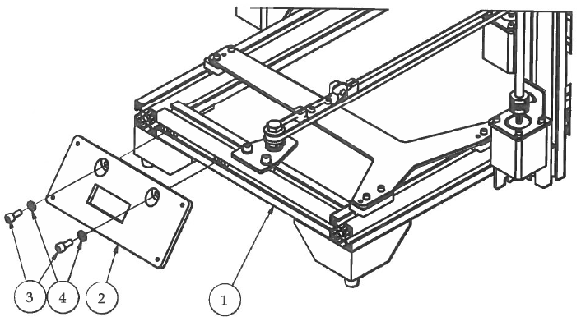Step 3

1. Attach the LCDpanelBoxBack to the font of the bottom frame using the existing T-Nuts and M5 hardware.
2. Make sure the left-outside of the bracket is flush with the left side of the bottom frame. This allows sufficient space when folding the crossbar down for shipping and/or transportation.

|  |  |  |  |
| --- | --- | --- | --- |
| **PARTS LIST** | | | |
| **ITEM** | **QTY** | **PART NUMBER** | **DESCRIPTION** |
| 1 | 1 | Step2 | Previous sub-assembly |
| 2 | 1 | LCDpanelBoxBack | 3D printed parts |
| 3 | 2 | M5 x 12 | Nuts and bolts |
| 4 | 2 | M5 Washer | Nuts and bolts |
|  |  | M4 Hex Wrench | Tools |

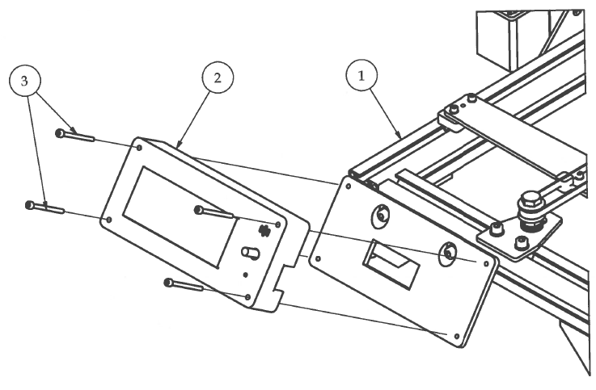Step 4

1. Attach the LCDscreenPanelBoxFront using M3 hardware. The M3 x 40 bolts will self-tap into the LCD Back Panel.
2. Make sure that the AC Power Switch is oriented in the correct position and that all of the wires to the LCD screen and AC power switch are placed through the rectangular window on the LCDscreenPanelBoxBack bracket before securing in place.

|  |  |  |  |
| --- | --- | --- | --- |
| **PARTS LIST** | | | |
| **ITEM** | **QTY** | **PART NUMBER** | **DESCRIPTION** |
| 1 | 1 | Step3 | Previous sub-assebmly |
| 2 | 1 | LCDscreenSubAssembly | Previous sub-assebmly |
| 3 | 4 | M3 x 40 | Nuts and bolts |
|  |  | M2.5 Hex Wrench | Tools |

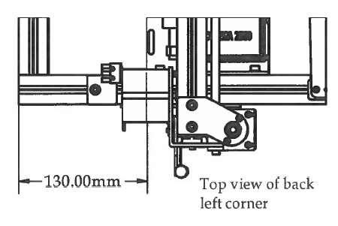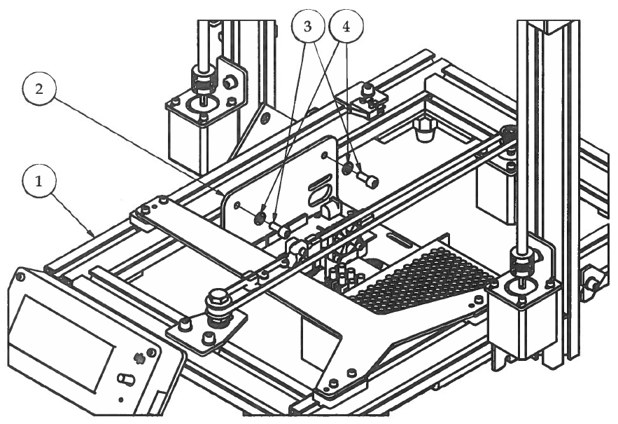Step 5

1. Attach the Electronics Tray sub-assembly to the bottom frame using the existing T-Nuts on the inside left and right slots and MS hardware.
2. Measure 130mm from the back of the Electronics Tray to the back of the bottom frame.
3. Secure in place.

|  |  |  |  |
| --- | --- | --- | --- |
| **PARTS LIST** | | | |
| **ITEM** | **QTY** | **PART NUMBER** | **DESCRIPTION** |
| 1 | 1 | Step4 | Previous sub-assembly |
| 2 | 1 | ElectronicsTraySubAssembly | Previous sub-assembly |
| 3 | 4 | M5 x 12 | Nuts and bolts |
| 4 | 4 | M5 Washer | Nuts and bolts |
|  |  | M4 Hex Wrench | Tools |

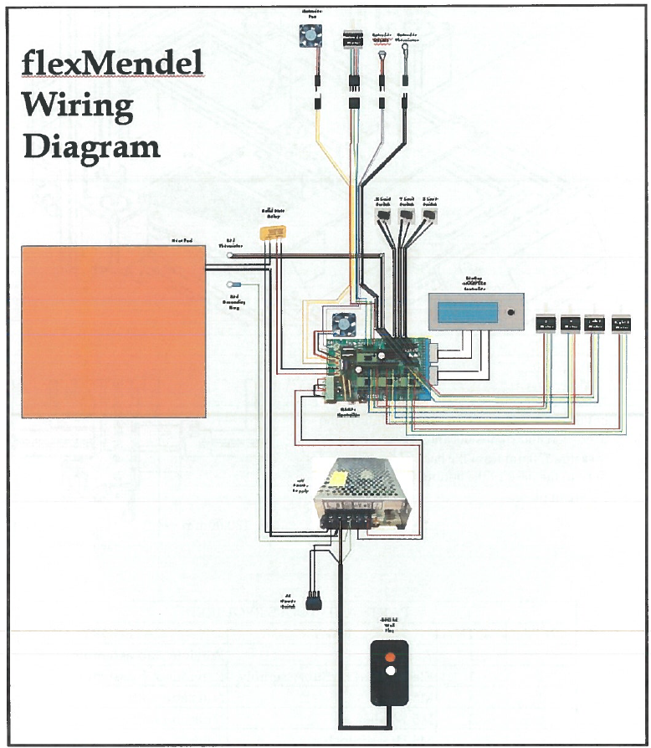Electrical Assembly

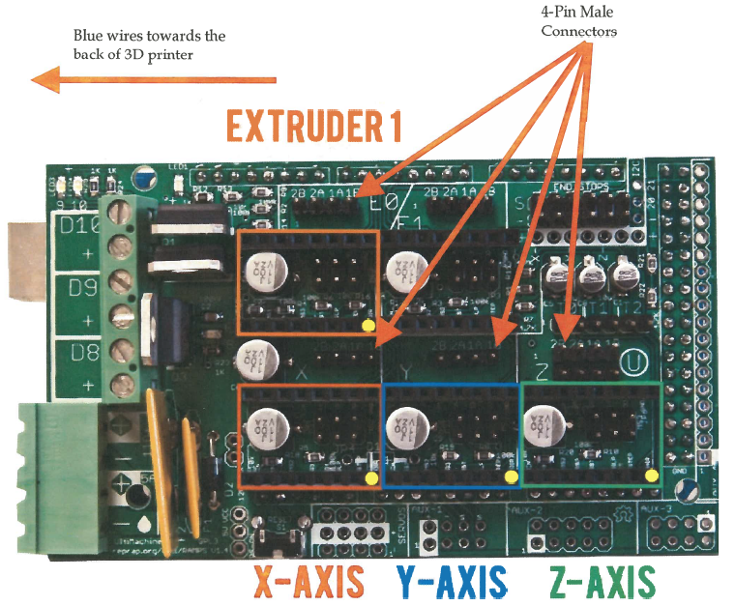

1. Plug X, Y, LZ, RZ and Extruder Motor wires into the 4-pin male connectors next to the appropriate stepper drivers. All motor wire plugs should have the BLUE WIRE TO THE BACK of the printer.

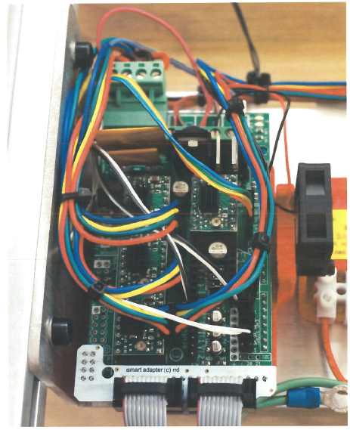RAMPs Magnified

1. Limit Switches are plugged into X-, Y-, and Z-
2. D8 Terminal is for heated bed signal wire that goes to the SS Relay
3. D9 Terminal is for both fans, RAMPs and Extruder Fans. Make sure that the RED wires get plugged into the POSITIVE (+) port.
4. D10 Terminal is Extruder Heater
5. T0 is for Extruder Thermistor
6. T1 is for Bed Thermistor
7. DC Power Input must have jumper wires in correct ports!

DC Power Supply Magnified

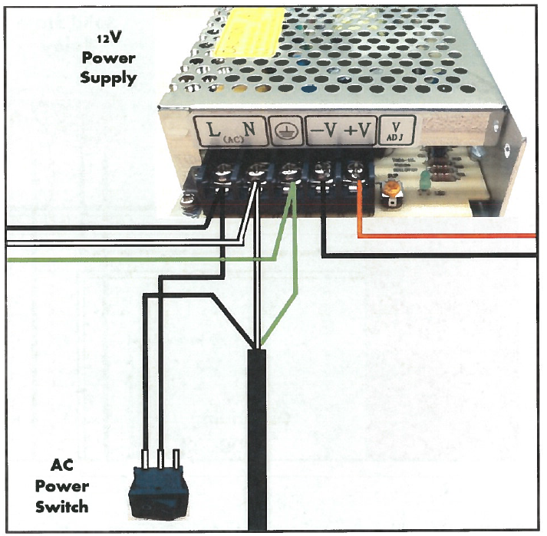

Heated Bed Magnified

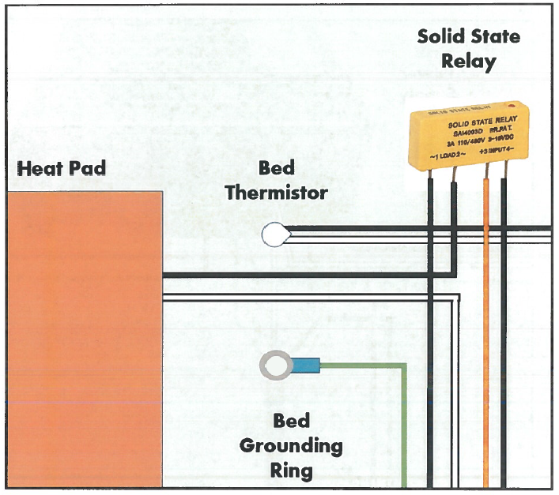

* Solid State Relay will have Euro-style connector to easily attach wires
* Bed Grounding Ring should be wired into the ground terminal on the power supply. This ensures that the entire frame is grounded.

# Heated Bed Assembly

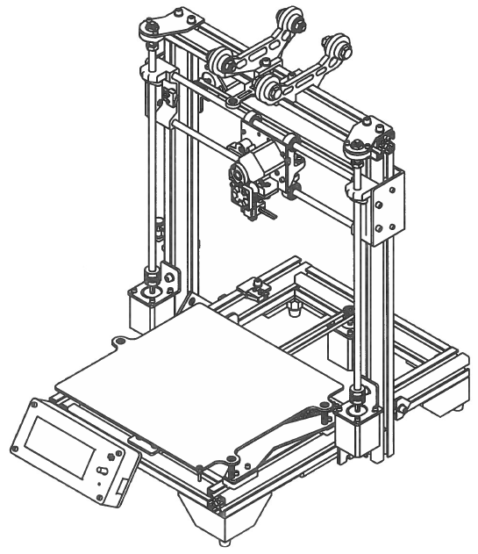

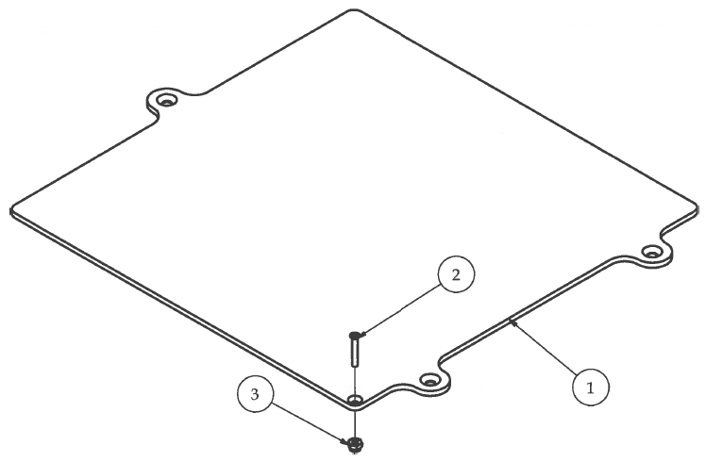Step 1

1. Secure the wire strain relief post to the Bed Plate using #4 hardware.

|  |  |  |  |
| --- | --- | --- | --- |
| **PARTS LIST** | | | |
| **ITEM** | **QTY** | **PART NUMBER** | **DESCRIPTION** |
| 1 | 1 | bedPlate V2_AL | Custom aluminum part |
| 2 | 1 | #4 x 3/4" Machine Screw | Nuts and bolts |
| 3 | 1 | #4 Nylock Nut | Nuts and bolts |

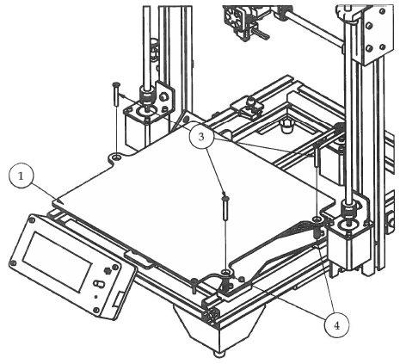Step 2

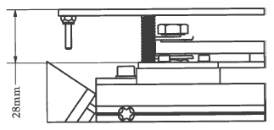

1. Attach the Bed Plate sub-assembly to the Y Carriage using the Compression springs and the #8 hardware. DO NOT OVER TIGHTEN BEDSCREWS!!!
2. Using a precision ruler, measure 28mm from the top of the Y Carriage to the top of the Bed Plate.

|  |  |  |  |
| --- | --- | --- | --- |
| **PARTS LIST** | | | |
| **ITEM** | **QTY** | **PART NUMBER** | **DESCRIPTION** |
| 1 | 1 | LimiSwitchesLCDpanelElectronicsTrayAssembly | Previous sub-assembly |
| 2 | 3 | #8 x 1 1/4" Machine Screw | Nuts and bolts |
| 3 | 3 | Compression Spring | Off-the-shelf components |
| 4 | 1 | Step1.1 |  |

Congratulations!!! You have finished build the flexMendel 3D printer!!!

Now it is time for calibration and then... TIME TO PRINT!!!

**Open Source flexMendel link:**

**Original designer and creator: Dave Kennell**

**Updated version OSC flex 1: Rob Martin**

**Open Source flexMendel: http://www.thingiverse.com/thing:251227**

# Mechanical Systems Test

## **Motor Jog Test:**

**X Motor Jog** - Click on Encoder → Prepare → Move Axis → X-Axis and turn the knob to the right. X+ should move the extruder to the right, X- should move the extruder to the left

**Y Motor Jog** - Click on Encoder → Prepare → Move Axis → Y-Axis and turn the knob to the right. Y+ should move the bedplate to the front, Y- should move the bedplate to the back

**Z Motor Jog** - Click on Encoder → Prepare → Move Axis → Z-Axis and turn the knob to the right. Z+ should move the Z axis up, Z- should move the Z axis down

Check the locations of the limit switches to ensure the action is clear

## **Calibrating the positions of Y and Z Limit Switches:**

**Set Y Limit Switch** - Loosen the M5 bolt that attaches the Y Limit Switch Bracket to the bottom frame. Slide the bed all the way to the back of the Y axis until it makes contact with the stepper pulley. Move the bed forward about 2mm. Slide the Y Limit Switch Bracket forward until the limit switch makes contact with the Y Carriage and clicks. Tighten the M5 bolt on the Limit Switch Bracket and you're set!

**Set Adjustable Z Limit Switch** - Adjustable Z Limit switch should be moved to the appropriate position so that the M3 x 20mm screw is centered in position after the Z axis is homed and the tip of the nozzle sits 0.3mm above the glass. See the "Bed Leveling" section of this manual for more detailed instructions on how to calibrate the Adjustable Z Limit Switch.

**Home All Axes** - Click on Encoder → Prepare → Auto Home → You should notice the flexMendel "Homing" each axis, X, Y, Z, respectively.

## **Check the Heating and Cooling Components:**

**Heating Elements** Check - Double check your Hot End and make sure that none of the extruder wires are touching any part of the Hot End before proceeding to the next step.

**To Preheat the flexMendel - Click on Encoder → Prepare → Preheat PLA**

Go back to the home screen on the LCD Smart Controller. You should see the temperatures in both the upper-left and upper-right corners on the screen increasing. **DO NOT TOUCH THE HOTEND OR THE HEATED BED!!!**

**Heated Bed** - After selecting Preheat PLA and returning to the home screen of the LCD Smart Controller, you should see different numbers in the upper left and right corners of the screen. The upper-left corner shows the temperature of the hotend (Actual Temp/ Set Temp) and the upper­ right corner shows the bed temperature (Actual Temp/ Set Temp). Both temperatures should be rising fairly quickly at this point. Make sure that the heated bed reaches the pre-set temperature and then stops heating. It may rise a few degrees above the set temperature, but will slowly fall. If the bed temperature rises to 10 degrees above the set temperature, turn the 3D printer off and check the thermistor wires where they plug into the RAMPs. It could be a possibility that you might have got the hotend thermistor and the bed thermistor mixed up.

**Hot End** - When you first turn on your Hot End, you may notice a little bit of smoke that escapes from the heater cartridge. This is normal and should only last a few seconds or so.

**Extruder Motor** - As a safety precaution, the flexMendel will not allow the Extruder motor to extrude unless the Hotend has been preheated to a minimum of 170° Celsius. Make sure Hotend is preheated.

**Click on Encoder → Prepare → Move Axis → Extrude**

If the filament shaft turns **COUNTERCLOCKWISE**, you have hooked up it up correctly. If it is spinning clockwise then reverse your extruder motor wire plug on the RAMPs Shield.

**Turning Off Heating Elements** -This will turn off all heating elements on the flexMendel 3D printer.

**Click on Encoder → Prepare → Cooldown**

**Fans Check** - Turn on the fans will help cool down the heating elements faster. You will want to check to make sure that both fans, Extruder fan and RAMPs shield fan, are running. If either of the fans fail to operate, overheating of either the Hot End or the RAMPs shield can cause serious damage to your flexMendel 3D printer.

**Click on Encoder → Control → Temperature →Fan Speed → Tum up to 255 → Click Encoder.**

To turn the fans off, simply reverse the above instruction.

Mechanical Systems Check Complete!!! If all systems are functioning properly, move onto the next step.

# **Setting up the flexMendel in the Classroom**

**Physical Location of the 3D Printer**

Selecting a room for a 3D printer is important for optimal operation. The room needs to provide a controlled environment to minimize potential problems that could affect the operation of the 3D printer and the quality of the parts being printed.

The room should provide:

* An area free of dust from other technical activities (i.e. saw dust, construction material debris, metal chips or flakes, etc.),
* Proper ventilation and temperature control (between 70-80° For 21-27° C),
* Steady and reliable source of electricity to power the 3D printer,
* A sturdy desk or workbench that the 3D printer can either be placed or mounted on, and
* An area away from HVAC vents and open windows to prevent air drafts from interfering with the 3D printing process.

The next step in setting up an optimum environment is to make sure that the desk or workbench is level for the 3D printer. The table or workbench should be sturdy and not have a wobbly leg. 3D printers move rapidly during operation, so they tend to vibrate whatever work surface they are sitting on. If the workbench is not sturdy and allows for excessive vibration, this extra movement can transfer to the finish quality of the 3D printed part, and you will be able to visually see imperfections on the surface of the part due to excessive vibration.

**Theft Prevention**

This section is to caution teachers that it is possible for a 3D printer to be stolen from the classroom. 3D printers are small and easily portable. They can be placed into a box or even a book bag in a matter of seconds, and some precautions should be made to prevent theft of the 3D printer. There are several things that can be done to prevent this from happening. 3D printers can easily be mounted to the workbench they are housed on, thus making it much more difficult to be stolen. They can also be locked up using a bike lock that is attached to the work bench or table. Another method for preventing theft is to place the 3D printer on a movable cart and simply move the cart to a room or closet that can be locked to prevent theft from occurring. This may seem a bit much, but there would be nothing worse than to have a class project be ruined by the disappearance of the 3D printer in the middle of the school semester

# Bedplate Leveling

This is one of the most important skills that a 3D printer operator will need to have because the first layer of a printed object determines all subsequent layers of that object. It also needs to be noted that with all types of 3D printers, the bed-leveling process may have a slightly different mechanical setup. This exercise is assuming that the 3D printer was assembled properly and the Z-limit switch is set at the appropriate height. If not, please refer to the manufacturer's directions of how to set the Z-limit switch.

We will examine three different mechanical setups, but the overall goal of leveling the bedplate is of the same importance with any 3D printer. Three points is the minimum number of points required to define a two dimensional plane. Most bedplates on 3D printers have three screws that • allow for the adjustment of the bedplate (X Y plane). The location of these three screws can vary depending on the 3D printer, but there are common characteristics of the bed-leveling screw positions. Two of the screws will be aligned on a single axis, either the X or the Y, and then the third screw is centered between the other two and offset a certain distance from the first two Screws.

Three different bedplate leveling screw positions for popular 3D printers are shown below. The black dots represent the position of the three adjustment screws for leveling the bed plate. It is also important to understand that the distance between the bed-leveling screws also plays a part in determining the difficulty in leveling the bed. This makes sense if you think about it. The closer together the bed-leveling screws are, the harder it will be to get the bed level because even the tiniest of adjustments will move the bedplate considerable distances. If the bed-leveling screws are placed far apart like the open-source flexMendel 3D printer, then making minor adjustments only moves the bedplate a minimum distance, thus giving the operator much more precise control when leveling the bedplate. Look at the diagrams below and identify the bed-leveling screws and their respective axis they lie on.

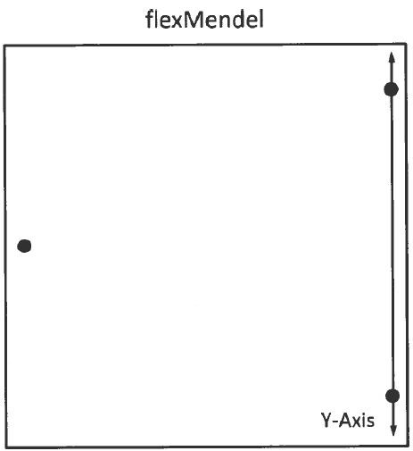

The first step in leveling the bed is to identify where the two adjustment screws are that align with either the X or Y-axis; these two screws should be leveled first with the tip of the extruder before moving on to the final adjustment screw. **When these two measuring points have been leveled**, they will remain level on their respective axis while adjusting the third and final adjustment screw because of the location of the screws.

**\*\*\* CAUTION\*\*\***

There is not much difference between electric motors and electric generators. Even when the 3D printer is turned off, the stepper motors can generate electricity if the extruder or bedplate are moved around too quickly. This will cause an electric current to flow backwards through the wires on the machine and can easily damage fragile electrical components on the 3D printer controller. Most electrical components on the circuit board are designed to respect polarity (hooking the positive and negative leads in a specific direction). When moving either the extruder or the bedplate, move them SLOWLY to not generate a surge of electricity that could damage the 3D printer's controller. Controller cost around $200 to replace.

**\*\*\* CAUTION \*\*\***

To begin the bed-leveling process, move the extruder so that the tip of the extruder is either on the imaginary line created by the first two adjustment screws or as close as possible to that line. Then move the bed so that the extruder is as far to one side of the bed as possible. See the black square with number 1 on the bedplate in the image below for suggestive extruder starting locations.

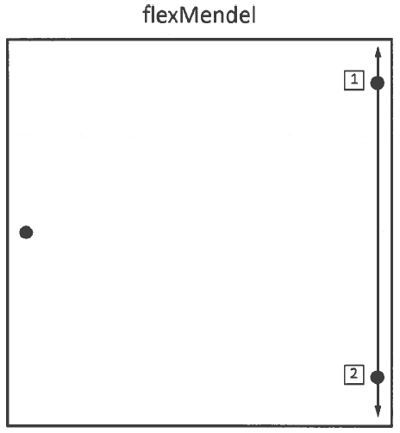

Place the piece of paper or the 0.25 mm feeler gauge between the tip of the extruder and the bedplate. If you cannot fit the feeler gauge in between the extruder and the bedplate or if there is a gap between the feeler gauge and the extruder, you will need to make some adjustments. Turn the adjustment screw closest to the extruder until the feeler gauge has friction from both the extruder and the bedplate. Be careful that the bedplate is not being pressed down on the springs when performing this exercise.

Move the bedplate or the extruder to the opposite end of the imaginary line described on the last page where the black box has a number 2 and repeat the leveling process described above. When you have completed this second leveling point, move the bedplate or extruder back to the original measuring point and recheck the distance with the feeler gauge. Make any adjustments as necessary, and then check the second measuring point again.

Move the bedplate or extruder so that the contact point is close to the edge of the bedplate by the third and final adjustment screw. Repeat the leveling process. Then move the bedplate or extruder so the contact point is on the opposite side of the bedplate, along the same respective axis.

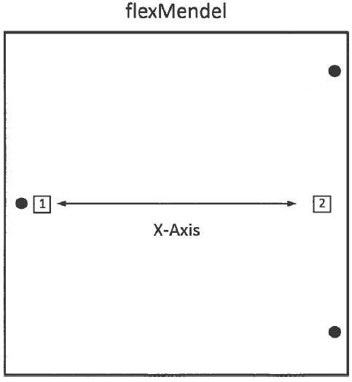

After completing all of the bed-leveling exercises, it is a good habit to move the extruder around all edges of the bedplate and check that the space between the extruder and bedplate is 0.25 mm.

The 3D printer should now be set up in an optimal environment for operation and mechanically calibrated to produce high quality printed parts.

# The Critical 1st Layer

The first layer of every object created using a 3D printer is always the most critical layer. Without good adhesion to the bedplate, the part has little chance of being created with the intended precision.

Although 3D printers are quickly becoming more reliable, during the first print layer, the operator needs to carefully inspect the machine's activity. Beyond the first layer, carefully watching the machine is not as critical. Most 3D printers extrude plastic material in layers that are around 0.3 mm thick. Leveling the bedplate to make the extruder nozzle parallel with the bedplate at a 0.3 mm height covering an area that is 200 mm x 200 mm or more is not an easy task. This is similar to trying to have a machine stay exactly 6 feet off the ground for the length of an entire football field.

With a little practice, the operator should be able to check the quality of the first layer with only a glance or two. They might need to make a few small adjustments to the 3D printer, but eventually these skills will become second nature.

Many things can happen during the first layer that can ruin a part. If the nozzle is too close or pressing against the bedplate on the first layer, it can prevent plastic from flowing out of the orifice, meanwhile new plastic continues to be forced into the extruder. This causes a back flow of plastic, and eventually the molten plastic will come out of the top of the extruder or force its way down the threads that attach the nozzle. If either of these things happen, the chances are high that the extruder has just been ruined, which would result in the user having to purchase a new one for around $60-$80.

The other extreme is with the tip of the extruder being too far away from the bedplate so that the plastic will to stick to the mirror. Although this may seem ok at first glance, later in the print, the part will begin to curl up its corners and eventually become detached from the bedplate. If the part is no longer attached to the bedplate, the machine's precision becomes worthless as it extrudes plastic into midair like spaghetti. The part is now ruined, and the time and money invested in printing this part is wasted. Below is a diagram that shows a profile view of various first layer heights.

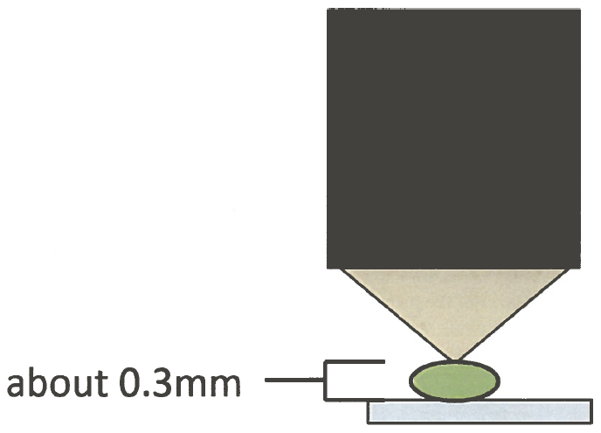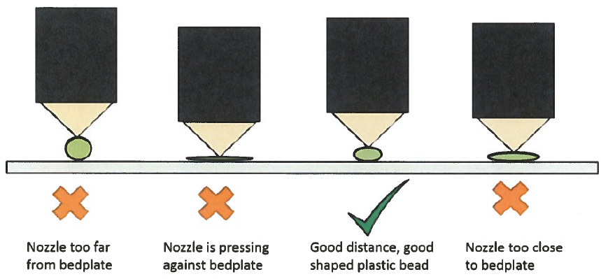

With the layer heights extruded from 3D printers being so tiny, you might ask, what is the best way to make sure the height is at the correct distance? Lots of companies insist that using a piece of paper or a feeler gauge is the best way, but this is not always true. Tension to one person between the nozzle and the feeler gauge could be interpreted differently to another. The best way is look at the bead of plastic that is being extruded from the nozzle. The best time to watch this bead of plastic is when the machine is creating the "skirt" (the first perimeter around the part). The operator should be able to see the size of the bead of plastic and judge whether it is too close or too far from the bedplate. With many open-source 3D printers, you can adjust the Z height on the fly, which truly allows every print the opportunity to be calibrated correctly while in motion. Many commercial printers have mechanical setups that do not allow for Z-height adjustment while in motion. This means that if the operator notices an incorrect height, the print must be stopped in order for the machine to be adjusted. In either situation, remember to take great care in watching the first layer of the print because it is a significant indicator as to whether the machine is going to continue making the part with no problems or if there is potential for a misprint.

# flexMendel Operation –

# RepRap Smart LCD Controller

The most popular open source 3D printer interface controller is the RepRap Smart LCD Controller. This controller completely frees the operator from having to connect the 3D printer to a computer at all. The RepRap Smart LCD Controller sells for around $50 and comes complete with hookup wires and pin attachment clips, an LCD screen, a click encoder for menu navigation, a SD card slot, and even a buzzer alarm that can be used to notify the operator of various functions within the 3D printer. It is extremely affordable and offers the user many great functions that are not available on some commercial 3D printers.

It is extremely easy to use and offers expanded functionality for the operator when calibrating the 3D printer or while it is in operation. This is very handy for times when calibration of the 3D printer needs to be made on the fly while the machine is in motion. Below is the complete RepRap Smart LCD Controller Menu Map, followed by Menu Option explanations and the 3D printing procedure and on-the-fly calibrations that can be made using this interface technology.

## RepRap Smart LCD Controller Menu Map:

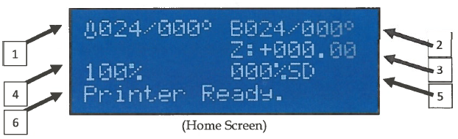Home Screen Display:

1. *Nozzle Temperature* - (Current temp/Set temp)
2. *Bedplate Temperature* - (Current temp/Set temp)
3. *Z Height* - (Measured in millimeters from home Z position)
4. *Machine Speed* Percentage - Can be turned up or down.
5. *% of SD File Completion* - An indicator of how much of the G-code file has been completed.

## To Print a File from the SD card:

1. 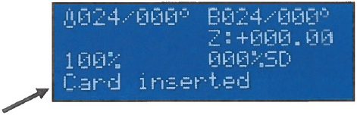Insert SD card with G-code file to print
2. 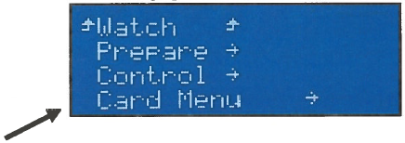Click the Encoder knob to bring up the Main Menu.
3. Turn the Encoder knob to scroll down to "Card Menu" and click the encoder.
4. Turn the Encoder knob to scroll down and find the G-code file that you want to print. Depending on how the files are organized on the SD card, there might be folders on the card that contain specific project G-code files. You can click on a folder to open it and see the files inside. When you locate the file that you want to print, click the encoder to select that file.

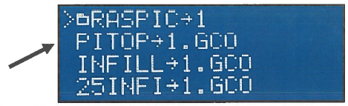

## 3D Printer calibration settings that can be changed on-the-fly:

1. Speed of the 3D Printer
   1. While at the home screen, simply rotate the encoder clockwise to increase speed percentage and counterclockwise to decrease speed percentage.
2. Nozzle or Bed Temperature and/or Fan Speed
   1. 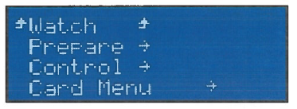Click the encoder to enter the Main Menu.
   2. Scroll down, and click on “Control.”

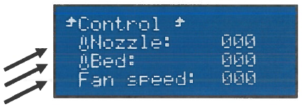

* 1. Scroll to either Nozzle, Bed, or Fan and click the encoder to enter change mode.
  2. When in change mode, simply rotate the encoder clockwise to increase temperature and/or speed, and turn counterclockwise to decrease temperature and/or speed percentage
  3. Click the encoder again to exit change mode.
  4. Scroll to the top and click on "Control" to go back to the Control screen.
  5. Click "Watch" to go back to the Home screen.

# Basic 3D Printer Operational Procedures

The basic process of operating a 3D printer is fairly simple. There are five major steps involved with using a 3D printer, and really only the last three steps are essential. The first two steps are optional because they assume that you are creating your own CAD model to be printed. The majority of 3D CAD models that are created using 3D printers were already created by someone else but are accessible through various open-source 3D printing websites like Thingiverse (www.thingiverse.com) or Instructables (www.instructables.com). In that case, all you would need to do is download the STL file, convert the STL file into a G-code, and then send it to the 30 printer to print. Below is a chart showing the basic 3D printer operational procedures.

1. If you are creating a new 3D model that you are going to print using the 3D printer, you will need to start by using some sort of 3D CAD modeling software to digitally develop the 3D model. Autodesk Inventor is the most popular 3D CAD modeling software in the educational system. There are also several open-source 3D CAD modeling software programs that are free and available on the Internet.
2. Once the 30 CAD model is complete, it is good practice to save the master file in a safe place for future reference. Often times, the user will need to make changes in the model after they print it out the first time and realize that some changes need to be made in order for the printed part to function optimally. In order to move to the next phase, you will need to "Export" the 30 CAD model into an STL file format. The STL file is necessary to send through the G-code file generator.
3. The next part of the process is where many people using 30 printers will start. They will need to obtain the STL file of the part that they wish to print. This is relatively easy, even if you did not create your own 30 CAD file. Thingiverse is the most popular STL file sharing website and contains over 100,000 projects that are published under open-source licenses so that anyone can download the STL files to be used with 30 printing. (See the guide on Thingiverse for specific directions of how to fully utilize the website.) After obtaining the STL file, it needs to be converted into a G-code file. The most popular G-code generator for 3D printing applications is by using the open-source program Slic3r. That program is as simple as loading the proper configuration file for the specific 3D printer, loading the STL file into Slic3r, and clicking on "Export G-code". In a few seconds the G-code file will have been created and is now ready to be sent to the 3D printer.
4. Sending the G-code file to the 3D printer is also a relatively easy process. Most often, the 3D printer will be equipped with an SD card reader. In that case, simply move the G-code file to be printed onto the SD card and insert the SD card into the 3D printer. If the 3D printer does not have an SD card reader and you are using a common 3D printer interface program like "Pronterface," then simply load the G-code file into the digital print bed in Pronterface to ready the file for printing.
5. After the G-code file is co1mected to the printer, either through Pronterface or on a SD card, then all that is left is to navigate the 3D printer menu and select the G-code file to be printed. The printer will then begin the preheating process, and when all set temperatures become stable, it will start the 3D printing process. It's that easy! You now know the process for 3D printing!

# flexMendel Maintenance

## Preventative Maintenance

Dust is probably a 3D printer's worst enemy. While dust is significantly small and often overlooked, it can cause continuous maintenance problems if not taken into consideration. Especially in a school setting with lots of students traveling in and out of classrooms, dust can easily become an issue if precautions are not taken.

Most 3D printers that are utilized in the classroom use plastic as their material for fabrication. Plastic is a non-conductive material. As it rubs together it creates a static charge. Since it is a non­conductive material, that charge will not have the ability to be transferred to other items connected to the ground allowing it to discharge. This makes the plastic on the reel of a 3D printer act like a magnet for dust.

Keep in mind that all of the plastic on the reel eventually all goes to the same place, the extruder. The diameter of the orifice on the extruder is usually around 0.35 mm. While dust particles may seem small, they will collect and build up inside the nozzle if they cannot pass through the orifice of the extruder. Eventually, when enough dust builds up inside the extruder, it begins to restrict the flow of plastic, thus creating a number of different problems. Printed parts start looking worse and worse, meanwhile the extruder is having to work harder to force the plastic through the hotend. Eventually it will completely clog the nozzle, and the molten plastic will back flow up the hotend and seep out the threads possibly ruining the heat core, thermistor, or the entire hotend altogether.

There is no solution that will completely prevent this from happening, but a little precautionary action can go a long way. Using a compressed air duster can, you can spray dust off of the reel before beginning a print. Compressed air dusters are cheap and work really well for removing dust build up on the reel. You can also take a small rag and wrap it around the plastic filament as a final dust cleaning before the plastic enters the extruder. After using the rag for a few days, remove and replace it with a new one. I think you will be amazed at the amount of dust that has accumulated on the rag, and then you will start to realize how much dust actually accumulates on the plastic reel during storage and operation. Below is a picture showing these low-tech solutions for dust.

## **Solutions to Minimize Damage from Dust**

One other easy inexpensive preventive maintenance activity is to cover the 3D printer with a plastic garbage bag while it is not in use. Covering the 3D printer while it is not in use will greatly reduce the amount of dust that can accumulate on the machine and/or the plastic reel.

It is also important to store the unused plastic filament in a large plastic tote with a lid or in a garbage bag. Preventing dust build up on the feedstock materials while they are in storage will minimize the potential problems that dust will cause the 3D printer. This will greatly extend the life of the hotend on your extruder. I have found that without dust prevention, a hotend will use between 5-10lbs of plastic before getting clogged and needing replacement with proper dust prevention teclmiques, the nozzle will be able to handle 30+ lbs of plastic before needing replacement. That extends the life of your equipment over three times!

Another factor that can clog nozzles is the quality of the plastic filament that is used. Just because you were able to get a low price in buying a lot of plastic from an unknown manufacturer does not mean that you got a good deal. Plastic filament can contain many particles inside the plastic that you can't see on the surface. These particles can also collect on the inside of the nozzle and cause clogging issues. When purchasing plastic filament for a 3D printer, paying a little extra for a high­ quality product can save lots of money in the long run. Plus, the 3D printer will produce better looking, higher quality printed parts.

## **Ongoing flexMendel Maintenance**

3D printer maintenance is an important topic when working with 3D printers. Many people believe that when they purchase a 3D printer it should work perfectly, right out of the box and they will never have to perform any types of maintenance activities. This is not true. A 3D printer is a machine and has many moving parts. There are a number of motors, gears, and belts that are constantly in motion and heating elements that will eventually need replacement. You wouldn't be able to drive an automobile for very long if you did not perform any type of regular maintenance on the machine. Periodically you have the oil changed, tires rotated, fluids and brakes checked, etc. Most people do not do their own maintenance on their automobile but recognize that it is an essential part of owning a car. This is true for almost any type of machine that has moving parts. 3D printers are not excluded from requiring maintenance. The maintenance required on a 3D printer is going to highly depend on the quality of the machine and the type of environment the machine is housed in. The quality of the automation components and the number of 3D printed parts on the machine also play a role in maintenance activities. Below is a list of common maintenance activities for 3D printers:

1. Replacing the nozzle and hotend components
2. timing belts if they become frayed
3. Adjust/ tighten bolts
4. Replacing 3D printed parts if they break
5. Re-calibrating the 3D printer
6. *Replacing the Nozzle and Hotend Components* -

Replacing a nozzle or other hotend components is probably the most common form of maintenance that will need to be performed on a 3D printer. When a nozzle gets clogged with dust and/ or dirt, it prevents molten plastic from flowing through the orifice at the tip of the nozzle. This causes plastic to backflow into the hotend and seep out the threads of the nozzle or even up into the entry hole for the plastic. Brand new nozzles can last anywhere from a week to a year depending greatly on the amount of time the machine is in operation and what types of preventative maintenance precautions have been taken. TI1e number one cause of cause of a clogged nozzle is dust. There a number of preventative maintenance activities that can be performed to mitigate dust from entering into the hotend (please see the preventative maintenance section for tips).

There are a few important items that need careful consideration when replacing a nozzle or a hotend. There are dozens of types of hotends available on the market today of varying qualities. When replacing a hotend, please follow the manufacturer's instructions that pertain to that particular hotend. One good aspect about most open source and commercial 3D printers is that they use a hotend that has a common size for mounting the component to the extruder.

When replacing a nozzle you need to check the orifice size on the nozzle and decide if you want to continue to use the same size. If you choose a different size orifice, make sure to update that change in your Slic3r settings. The next thing that requires careful consideration is the type of thermistor that will be used on your new hotend. Try to find the same type of thermistor you have on your existing hotend. If you switch hotends, you might have a new type of thermistor that needs to be accounted for in the firmware of your 3D printer. It is easy to update the type of thermistor in the firmware. Simply open the Arduino Firmware file that came with the 3D printer, go to the "Configuration.h" tab and scroll down until you find the "Thermal Settings". It will look something like this:

//==========================================================

//====================Thermal Settings ====================

//==========================================================

//// Temperature sensor settings:

// -2 is thermocouple with MAX6675 (only for sensor 0)

// -1 is thermocouple with AD595

// 0 is not used

// 1 is 100k thermistor

// 2 is 200k thermistor

// 3 is mendel-parts thermistor

// 4 is 10k thermistor !!do not use it for a hotend. It gives

// bad resolution at high temp.!!

// 5 is ParCan supplied 104GT-2 100k

// 6 is EPCOS 100k

// 7 is 100k Honeywell thermistor 135-104LAG-J01

#define TEMP_SENSOR_0 1 //use 5 for JHead

#define TEMP_SENSOR_1 0

#define TEMP_SENSOR_2 0

#define TEMP_SENSOR_BED 1

Contents

Limit Switches, Electronics Tray, and LCD Screen 96

Electrical Assembly 104

Heated Bed Assembly 109

Mechanical Systems Test 113

**Motor Jog Test:** 113

**Calibrating the positions of Y and Z Limit Switches:** 113

**Check the Heating and Cooling Components:** 114

**Setting up the flexMendel in the Classroom** 116

Bedplate Leveling 117

The Critical 1st Layer 121

flexMendel Operation – 124

RepRap Smart LCD Controller 124

RepRap Smart LCD Controller Menu Map: 125

To Print a File from the SD card: 126

3D Printer calibration settings that can be changed on-the-fly: 127

Basic 3D Printer Operational Procedures 128

flexMendel Maintenance 130

Preventative Maintenance 130

**Solutions to Minimize Damage from Dust** 131

**Ongoing flexMendel Maintenance** 132